Birmingham Metro Home Sales
August 2018

► Total residential sales in August 2018 were 1458 compared to 1445 in August a year ago (no significant change) Year to date sales =10778, +5.5%
► Average price in August 2018 was $250,335 compared to $235,548 in August a year ago (6% increase)
► Median price in August 2018 was $208,700 compared to $194,900 in August 2017 (7% increase)
► Inventory totaled 5779 for August 2018 compared to 6455 in August 2017 (10% decrease)

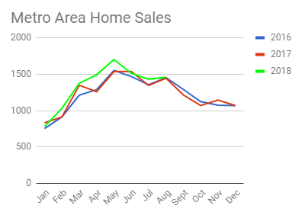

After eight months in 2018, local home sales were 5.5% ahead of 2017 at the same time. There were 10% fewer homes on the market in August compared to August of 2017. The average price was up 6%. Buyers are paying more and working much harder to find a home.Some are disappointed to find themselves in direct competition with other buyers, bidding on the same house, driving prices even higher.

The chart above shows the seasonal decline in sales that occurs every year at this time. Sales will continue to decline each month until we reach the annual low in January. Inventories are low in communities across the metro area but competition among buyers seems to easing.

There is still significant energy in the local market. If you know anyone wanting to sell a home, please pass my name along.

Regards,
Joe Billmeier
Real Estate Broker
205.223.4043

